EUROPEAN COURT OF HUMAN RIGI-ITS COUR EUROPÉENNE DES DROITS DE L'HOMME

DECISION

CASE OF M.H. AND OTHERS v. ITALY

(App/ication no. 34145/18)
introduced on 23 July 2018

The European Court of Human Rights, sitting on 7 February 2019 in a single-judge formation pursuant to Articies 24 § 2 and 27 of the Convention, has examined the application as submitted.

The Court, relying on its case-law (see, in particular, Petrache and Tronca v. ltaly {dee. ), 04 October
2016, Barahona Guachamin and others v. ltaly (dee.}, §56, 04 December 2018 and Hamidovic v. ltaly
{dee. }, 13 September 2011), finds in the light of ali the materia! in its possession and in so far as the matters complained of are wlthin its competence, that they do not disclose any appearance of a violation of the rights and freedoms set aut in the Convention or the Protocols thereto and that the admissibility criteria set aut in Articies 34 and 35 of the Convention have not been met.

The Court declares the application inadmissible.

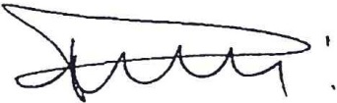

Georges Ravarani
Judge

COUNCIL OF EUROPE

